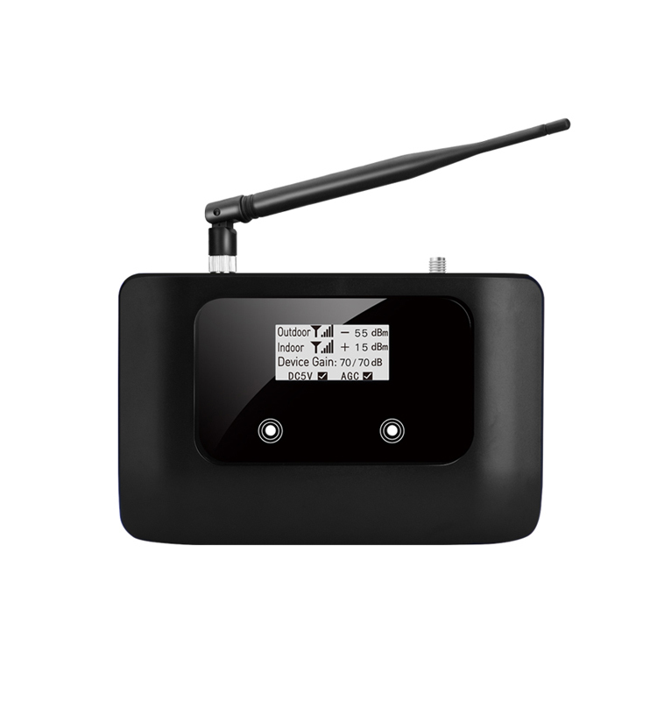
Band 28 700MHz Wid band Repeater
Model: AS-L

Product Features:
- Improve any two mobile networks at the same time
- LCD display the input/output signal strength
- Auto isolation detect function
- Auto gain control ,auto level control
- Auto uplink noise reduction,avoid disturbing to BTS
- Smart LCD to guide the installation

Working Schematic Diagram
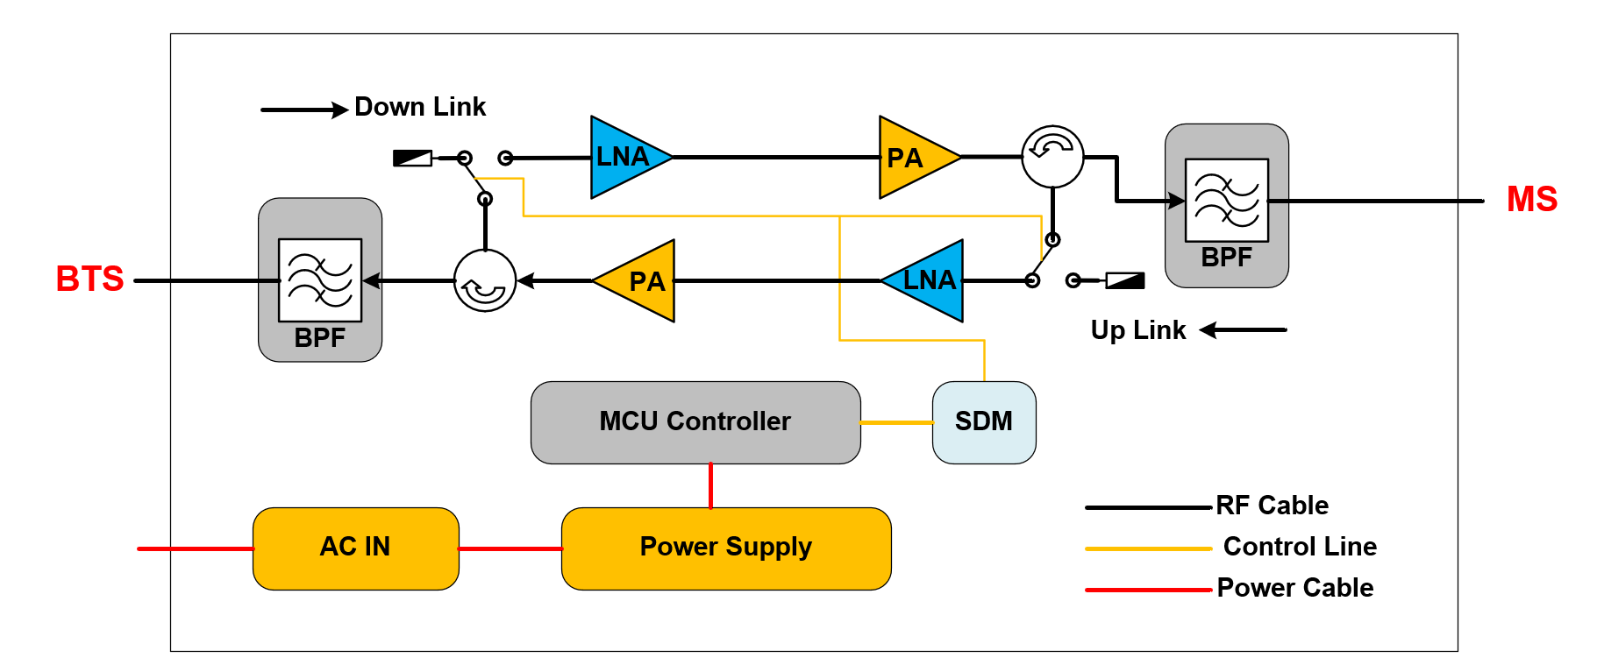Application Scenario:
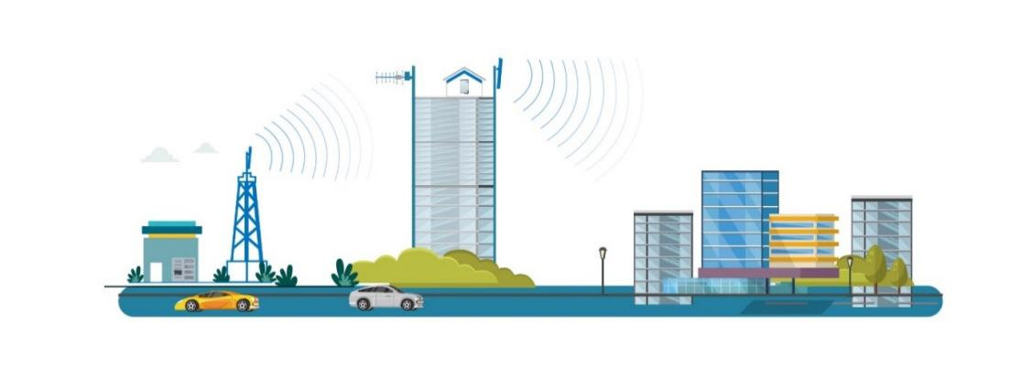

Technical Specifications:
P/N: AS-L |  | B28 ( 700MHz)
Frequency Range | Uplink | 703-748MHz
Frequency Range | Downlink | 758-803MHz
Bandwidth |  | 35MHz
Max. Gain | Uplink | 60±3 dB
Max. Gain | Downlink | 70±3 dB
Manual Gain Control |  | 31 dB in step of 1 dB
Automatic Gain Control |  | ≧ 20 dB
Gain Flatness (per sub-band) |  | ≦ ±3 dB (peak-to-peak)
Max. Input Power Without Damage |  | 0 dBm
Output Power | Uplink | 17±2 dBm
Output Power | Downlink | 20±2 dBm
Spurious Emission | 9KHz-1GHz | ≦ -36dBm
Spurious Emission | 1GHz-12.75GHz | ≦ -30dBm
ACRR | ±20/100MHz | ≦-36dBc/30KHz
ACRR | ±40/200MHz | ≦-40dBc/30KHz
EVM |  | ≦ 8 %
Frequency Stability |  | ≦ ±0.01 ppm
Noise Figure |  | ≦ 8 dB
VSWR |  | ≦ 2
System Delay |  | ≦ 3 µs
RF Connector |  | SMA-Female
Impedance |  | 50 Ω
Power Supply |  | DC 5V2A
Power Consumption |  | ≦ 15 W
Dimensions |  | 165*115*35mm
Weight |  | ≦ 0.5 kgs
IP Rating |  | IP40
Operating Temperature |  | -25 °C to 55 °C
Technical specification is subject to change without prior notice.

